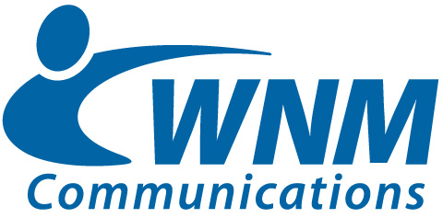
For more information, please contact:
Kandra Young, Marketing and Public Relations Director
575-597-0047

WNM Communications’ Daniel Meszler named to the NM Fiber Network Leadership Team.
FOR IMMEDIATE RELEASE
Silver City, NM, 9/13/22 – WNM Communications, Southwest New Mexico’s hometown communications and broadband company, is excited to announce that their General Manager, Daniel Meszler, has been appointed as Secretary of the NM Fiber Network Leadership Team. This comes as the state-wide fiber network looks to make great strides in implementing fiber projects and recognizes that coordination between New Mexico companies, leaders and organizations is crucial for success.
WNM Communications is one of the eleven founding owner-members of the New Mexico Fiber Network. The network is stacked with both resources and experience, totaling over 700 employees and an average of 60 years of experience across the member organizations.
The NM Fiber Network will provide high-speed fiber optic backbone capabilities that will benefit other telecommunications providers as well as direct business customers including but not limited to government agencies, schools and hospitals.
Meszler will serve alongside a newly appointed group of strong leaders including CEO, Joshua Beug of Tularosa Communications; Vice-Chairman, Nectarios “Neo” Nicolaou of Sacred Wind; CFO, Troy Judd of Valley Telephone Cooperative; and COO, Jason Gonzalez of Plateau Telecommunications.
“WNM Communications is excited to be a part of NM Fiber network,” Meszler said. “This is a great opportunity to expand fiber connectivity throughout the state.”
WNM Communications looks forward to having their hand in the growth of an organization that has the potential to change broadband and improve connectivity across New Mexico.

